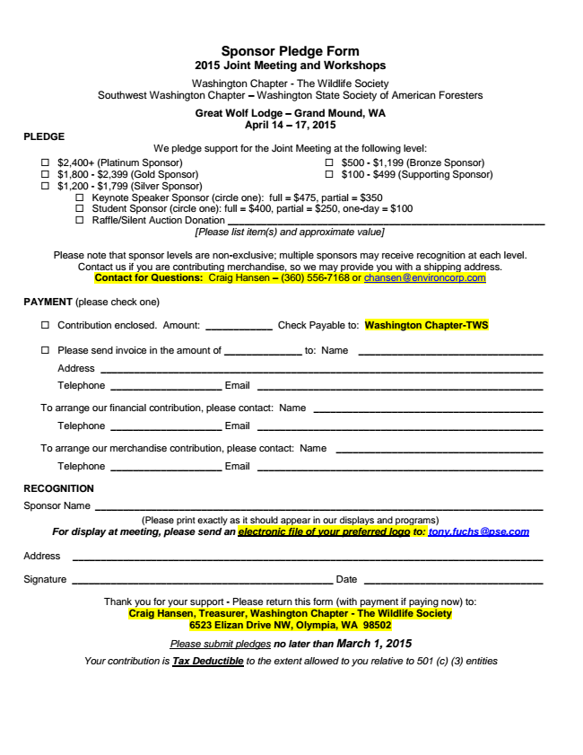

**Sponsor Pledge Form 2015 Joint Meeting and Workshops**

Washington Chapter - The Wildlife Society Southwest Washington Chapter – Washington State Society of American Foresters

**Great Wolf Lodge – Grand Mound, WA April 14 – 17, 2015 PLEDGE**

We pledge support for the Joint Meeting at the following level:

□ $2,400+ (Platinum Sponsor)

□ $1,800 - $2,399 (Gold Sponsor)

□ $1,200 - $1,799 (Silver Sponsor)

□ $500 - $1,199 (Bronze Sponsor)

□ $100 - $499 (Supporting Sponsor)

□ Keynote Speaker Sponsor (circle one): full = $475, partial = $350

□ Student Sponsor (circle one): full = $400, partial = $250, one-day = $100

□ Raffle/Silent Auction Donation _________________________________________________________

*[Please list item(s) and approximate value]*

Please note that sponsor levels are non-exclusive; multiple sponsors may receive recognition at each level. Contact us if you are contributing merchandise, so we may provide you with a shipping address. Contact for Questions: Craig Hansen – (360) 556-7168 or chansen@environcorp.com

PAYMENT (please check one)

□ Contribution enclosed. Amount: ____________ Check Payable to: Washington Chapter-TWS

□ Please send invoice in the amount of ______________ to: Name _________________________________

Address _______________________________________________________________________________

Telephone ____________________ Email ___________________________________________________

To arrange our financial contribution, please contact: Name _________________________________________

Telephone ____________________ Email ___________________________________________________

To arrange our merchandise contribution, please contact: Name _____________________________________

Telephone ____________________ Email ___________________________________________________

**RECOGNITION**

Sponsor Name ________________________________________________________________________________

***(Please print exactly as it should appear in our displays and programs) For display at meeting, please send an electronic file of your preferred logo to: tony.fuchs@pse.com***

Address ____________________________________________________________________________________

Signature _______________________________________________ Date ________________________________

**Thank you for your support - Please return this form (with payment if paying now) to: Craig Hansen, Treasurer, Washington Chapter - The Wildlife Society 6523 Elizan Drive NW, Olympia, WA 98502**

*Please submit pledges no later than March 1, 2015*

*Your contribution is Tax Deductible to the extent allowed to you relative to 501 (c) (3) entities*

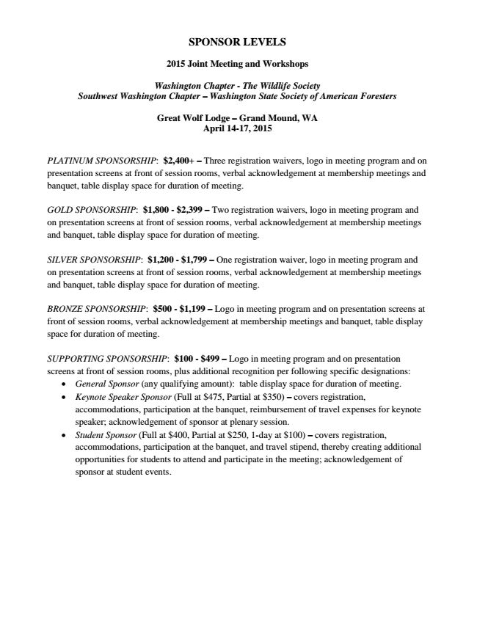

**SPONSOR LEVELS**

**2015 Joint Meeting and Workshops**

***Washington Chapter - The Wildlife Society Southwest Washington Chapter – Washington State Society of American Foresters***

**Great Wolf Lodge – Grand Mound, WA April 14-17, 2015**

PLATINUM SPONSORSHIP: $2,400+ – Three registration waivers, logo in meeting program and on presentation screens at front of session rooms, verbal acknowledgement at membership meetings and banquet, table display space for duration of meeting.

GOLD SPONSORSHIP: $1,800 - $2,399 – Two registration waivers, logo in meeting program and on presentation screens at front of session rooms, verbal acknowledgement at membership meetings and banquet, table display space for duration of meeting.

SILVER SPONSORSHIP: $1,200 - $1,799 – One registration waiver, logo in meeting program and on presentation screens at front of session rooms, verbal acknowledgement at membership meetings and banquet, table display space for duration of meeting.

BRONZE SPONSORSHIP: $500 - $1,199 – Logo in meeting program and on presentation screens at front of session rooms, verbal acknowledgement at membership meetings and banquet, table display space for duration of meeting.

SUPPORTING SPONSORSHIP: $100 - $499 – Logo in meeting program and on presentation screens at front of session rooms, plus additional recognition per following specific designations:

• General Sponsor (any qualifying amount): table display space for duration of meeting.

• Keynote Speaker Sponsor (Full at $475, Partial at $350) – covers registration, accommodations, participation at the banquet, reimbursement of travel expenses for keynote speaker; acknowledgement of sponsor at plenary session.

• Student Sponsor (Full at $400, Partial at $250, 1-day at $100) – covers registration, accommodations, participation at the banquet, and travel stipend, thereby creating additional opportunities for students to attend and participate in the meeting; acknowledgement of sponsor at student events.